Ishika Gupta

**Final Project-Econometrics**

Quantitative analysis of men and women professional tennis players over recent years has shown that females are less competitive than men. Tennis rankings work based on a points system that adds up players’ 18 best results in the previous 52 weeks. To earn ranking points, tennis players must participate in events hosted by the International Tennis Federation (ITF), the Association of Tennis Professionals (ATP), and the Women’s Tennis Association (WTA). The Grand Slam tournaments, also referred to as majors, are the world's four most important annual professional tennis events that offer the most ranking points. The four yearly Grand Slam Tennis Tournaments (GST), the Australian Open, French Open, Wimbledon, and US Open, are the most competitive and prestigious professional tennis tournaments in which the best players of the world are expected to participate. Winning Grand Slam Tournaments and maintaining GST dominance is the utmost achievement for a professional tennis player as their names are “carved in stone” at the stadium where they won their title. The number of points earned by the player depends on the round the player loses. A professional tennis player’s ability to enter tournaments is determined by their ranking. The closer the player’s ranking is to 1, the higher the likelihood of them being able to participate in the main draw of a tournament. The goal of this research is to analyze the determinants that affect a player’s ranking and whether females are actually less competitive than men.

Rankings affect the seed of a player. The top 16 or 32 ranked players participating in a tournament are given seeds. Del Corral (2009) studied the effect of seeding system on competitive balance. They found that the outcome of the change in the seeding system differed by sex. In particular, competitive balance decreased significantly for men. For women, no significant effect on competitive balance was incurred as a result of the change. Moreover, the competitive balance measured by the performance of seeded players is much higher for men than for women (del Corral 2009, 578).

The dataset used in this study has 37,367 observations with winner and loser match statistics of professional ATP and WTA tennis players. The dataset was obtained from Kaggle by combining ATP and WTA match statistics from years 2000 to 2005. It includes the name of the tournament, surface the tournament was played in (carpet, clay, hard grass), draw size, country of the player, round and score of the match, dominant hand of the player, match length, winner and loser rank, seed, height, age, number of aces served, number of double faults, number of service points played, number of first serves in, number of first serve points won, number of service games played, number of break points saved, and the number of break points faced. Tables 2 and 3 show the summary statistics of the variables used in the regression. The maximum value for the dependent variable (winner_rank) is 1,479 and the minimum is 1 for 35,596 observations. We found the mean to be 83.57 and standard deviation to be 136.1. The maximum value for w_ace (number of aces served by the winner) is 46 and minimum is 0 for 18,677 observations. An average winner serves 6.261 aces in a match. The maximum value for w_df (number of double faults served by the winner) is 21 and minimum is 0 for 18,673 observations. An average winner serves 2.938 double faults in a match.

Given the institutional differences between tennis tournaments for females and males, it is important to consider some of the limitations of the data being used for this study. For example, the tennis circuit for females consists of less tournaments than for females and there are a greater number of males playing the sport as compared to females. The greater number of males playing is also reflected in the rankings as female rankings do not go a lot lower than the top 1000 while males do (David 2012, 161).

We estimated a simple linear regression for our cross-sectional model to analyze the effect of winner and loser statistics on the ranking of the player. The regression equation of winner statistics on winner rank is given below:

$γ_{i}= B_{0}+ B_{1}X_{1}+ B_{2}X_{2}+B_{3}X_{3}+B_{4}X_{4}+B_{5}X_{5}+B_{6}X_{6}+B_{7}X_{7}+B_{8}X_{8}+ϵ_{i}$**1**

where,

i = Winner Rank, X1 = female, X2 = age of the winner, X3 = height of the winner, X4 = dominant hand of the winner, X5 = aces served by the winner, X6 = double faults served by the winner, X7 = number of first serves in for the winner, X8 = break points saved by the winner.

The regression equation of winner statistics on winner rank is given below:

$γ_{i}= B_{0}+ B_{1}X_{1}+ B_{2}X_{2}+B_{3}X_{3}+B_{4}X_{4}+B_{5}X_{5}+B_{6}X_{6}+B_{7}X_{7}+B_{8}X_{8}+ϵ_{i}$**2**

where,

i = Loser Rank, X1 = female, X2 = age of the loser, X3 = height of the loser, X4 = dominant hand of the loser, X5 = aces served by the loser, X6 = double faults served by the loser, X7 = number of first serves in for the loser, X8 = break points saved by the loser.

The variables included in the regression are unambiguous and theoretically sound. By estimating a ttest (figure 1), we found that the t-statistic was 2.7941 and the p-value was 0.0052 which means that the variable is statistically significant at the 10% level in the expected direction. Hence, we can reject the null in favor of the alternative and say that rankings for female and male winners are not the same. Sometimes $B_{0}$ is of theoretical importance because if we exclude $B_{0},$ our y-intercept is zero and its impact is forced into other coefficients.

We first estimated a simple linear regression to show the impact of the dummy variable female on winner rank (figure 2). We found the beta coefficient to be -4.038085 which means that for every female player, their ranking decreases by -4.04 units as compared to a male player. This variable is statistically significant at the 1% level. The r-squared which is a measure of goodness of fit is 0.0002. By adding other control variables, we found that the beta coefficient for female was -24.63325 which means that for every female player, their ranking decreases by -24.63 units as compared to a male player, ceteris paribus. This corresponds with our theory that females are ranked lower than men. The results are robust since the variables are statistically significant in the same direction for both univariate and multivariate models. The coefficient for winner’s age is -.0976878 and it is not statistically significant since the p-value is 0.505, so it is essentially zero. The coefficient for winner’s height is .3363545, which means that for every one centimeter increase in height, their ranking increases by 0.33 units, ceteris paribus. This variable is statistically significant at the 1% level. The coefficient for winnerhand (dominant hand of the player) is -19.08511, which means that for every right-handed player, their ranking decreases by 19.09 units, ceteris paribus. This means that right-handed players have a comparatively better rank than left-handed players. This variable is statistically significant at the 1% level. The coefficient for w_ace (number of aces served by the winner) is -.6471431, which means that for every one unit increase in the number of aces, their ranking decreases by 0.65 units (a lower ranking is better), ceteris paribus. This theoretically makes sense as an increase in the number of aces should increase in the number of points won. This increases the likelihood of winning a match and hence, it improves the player’s ranking. This variable is statistically significant at the 1% level. The coefficient for w_df (number of double faults served by the winner) is 1.491292, which means that for every one unit increase in the number of double faults, their ranking increases by 1.49 units, ceteris paribus. This variable is statistically significant at the 1% level. The coefficient for w_1stin (number of first serves in by the winner) is .0869866, which means that for every one unit increase in the number of first serves in, their ranking increases by 0.87 units, ceteris paribus. This variable is statistically significant at the 5% level. The coefficient for w_bpsaved (number of break points saved by the winner) is .1087383 and is not statistically significant. Even if some of the independent variables are insignificant, it might belong in our model and dropping it may cause bias. We found that the overall fit of the equation increased on adding control variables since r-squared increased to 0.0202.

We estimated our theoretical regression as follows:

$$γ_{i}\left( Rank\right)= B_{0}+ B_{1}{female}_{1}+ B_{2}{age }_{2}+B_{3}{height }_{3}+B_{4}{dominant hand}_{4}+B_{5}{aces served}_{5}+B_{6}{double faults}_{6}+B_{7}{first serves in}_{7}+B_{8}{break points saved}_{8}+B_{9}{points earned}_{9}+B_{10}{mental toughness}_{10}+ ϵ_{i}$$

Our estimated regression is as follows:

$$γ_{i}\left( Rank\right)= B_{0}+{B_{1}female}_{1}+ B_{2}{age }_{2}+B_{3}{height }_{3}+B_{4}{dominant hand}_{4}+B_{5}{aces served}_{5}+B_{6}{double faults}_{6}+B_{7}{first serves in}_{7}+B_{8}{break points saved}_{8}$$

By excluding points earned by performing in the tournament and mental toughness in our estimated equation, we have the problem of omitted variable bias, where our estimates of the true impact of the variables is biased.

$$γ_{i}\left( Rank\right)= B_{0}+ B_{1}{female}_{1}+ B_{2}{age }_{2}+B_{3}{height }_{3}+B_{4}{dominant hand}_{4}+B_{5}{aces served}_{5}+B_{6}{double faults}_{6}+B_{7}{first serves in}_{7}+B_{8}{break points saved}_{8}+B_{9}{points earned}_{9}+B_{10}{mental toughness}_{10}+ ϵ_{i}^{*}$$

Where $ϵ_{i}^{*}$ = $ϵ_{i}$ + ${B_{2}points earned}_{2}+B_{3}{mental toughness}_{3}$

If we do not have data on points earned and mental toughness of the player, they are included in the error term ( $ϵ_{i}^{*}$) causing endogeneity since points earned seem to be correlated with the age, height, aces served, doubles faults served by the player and mental toughness also seems to be correlated with first serves in and break points saved by the player.

E ($β_{2}^{*})= β_{2}+β_{9} * α_{1 }$, where $α_{1 }$ is an estimate of the slope coefficient from a secondary regression that relates points earned with the age of the player.

$$Points earned= α_{0 }+ α_{1 }Age$$

Bias = $β_{9} α_{1 }$ which is the amount of expected bias caused by omitting points earned. $β_{9}$ has an expected sign of negative since a higher number of points earned leads to a lower (better) ranking. $α_{1 }$ has an expected sign of negative since an increase in age will reduce the likelihood of performing better in a tournament and hence lead to a lower number of points earned. The presence of a negative bias in the results indicates that the estimated regression results should be interpreted as lower bounds of the true estimates.

E ($β_{8}^{*})= β_{8}+β_{10} * α_{2 }$, where $α_{2 }$ is an estimate of the slope coefficient from a secondary regression that relates mental toughness with the break points saved by the player.

$$Mental toughness= α_{1 }+ α_{2 }Break points saved$$

Bias = $β_{10} α_{2 }$ which is the amount of expected bias caused by omitting points earned. $β_{10}$ has an expected sign of negative since a greater mental toughness leads to a lower (better) ranking. $α_{1 }$ has an expected sign of positive since an increase in the number of break points saved means that the player has higher mental toughness. The product of these coefficients is negative and the presence of a negative bias in the results indicates that the estimated regression results should be interpreted as lower bounds of the true estimates.

To analyze any econometric problems we might encounter and check for robustness, we estimate results for multicollinearity and heteroskedasticity. Multicollinearity exists in every equation, but its magnitude and severity can change from sample to sample. We estimated a simple correlation coefficient and a variance inflation factor test (VIF) and found all coefficients to be less than 0.5 and the mean VIF to be 1.31 which is less than 10. This means that there is in no evidence of multicollinearity and no evidence of any relationship between the independent variables. Heteroskedasticity exists when there is great variance of the dependent variable. We estimated both the White test and the Breusch-Pagan test to check for heteroskedasticity. The White test investigates whether the squared residuals can be explained by the equation’s independent variables, their squares, and their cross-products. As the number of explanatory variables in original regression rises, the number of right-hand variables in the White test auxiliary goes up much faster. The Breusch-Pagan investigates whether the squared residuals can be explained by possible proportionality factors. We set up the null and alternative hypothesis as follows:

* H0 : constant variance of the error term (homoskedasticity)

* Ha: Heteroskedasticity or non-constant variance

We found evidence to reject the null in favor of the alternative since the chi-squared was 381.18 (Breusch-Pagan) and 285.17 (Breusch-Pagan) and the p-value was 0.0 in both tests which means that there is evidence of heteroskedasticity. If heteroskedasticity is found, the first thing to do is examine the equation carefully for specification errors. If there are no obvious specification errors, the heteroskedasticity is probably pure in nature. Pure heteroskedasticity does not cause bias in the coefficient estimates. Heteroskedasticity typically causes OLS to no longer be the minimum variance estimator (of all the linear unbiased estimators). Heteroskedasticity causes the OLS estimates of the standard errors to be biased, leading to unreliable hypothesis testing and confidence intervals.

We found statistical evidence that females are ranked lower than men which also implies that they are less competitive than men. There are possibilities of future research from the findings derived in this paper. We can use the effects of seeding system and ranks to determine how the competitive balance would change for different surfaces of the court. We could also use models from this paper to determine whether the location of a tournament has any effect on the players performance. For example, is Rafael Nadal expected to perform better in Spain as compared to other countries. Furthermore, future research will explore the implications of the findings on tennis betting markets.

Bibliography:

del Corral, Julio. “Competitive Balance and Match Uncertainty in Grand-Slam Tennis.” *Journal of Sports Economics* 10, no. 6 (2009): 563–81. <https://doi.org/10.1177/1527002509334650>

Feldman, David, Shulamith T. Gross, and Yang Long. “Gender Competitiveness and Predictability, and Prize Money in Grand Slam Tennis Tournaments.” Quarterly Journal of Finance 10, no. 02 (2020): 2050006. <https://doi.org/10.1142/s2010139220500068>

Kowalik, Zuzanna, and Piotr Lewandowski. “The Gender Gap in Aversion to Covid-19 Exposure: Evidence from Professional Tennis.” SSRN Electronic Journal, 2020. <https://doi.org/10.2139/ssrn.3708630>

Wendling, Elodie, and Brian M. Mills. “Mitigation of Relative Age Effects through Targeted Policy Intervention: A Natural Experiment from Professional Tennis.” Social Science Quarterly 99, no. 4 (2018): 1496–1509. <https://doi.org/10.1111/ssqu.12516>

Wozniak, David. “Gender Differences in a Market with Relative Performance Feedback: Professional Tennis Players.” Journal of Economic Behavior & Organization 83, no. 1 (2012): 158–71. <https://doi.org/10.1016/j.jebo.2011.06.020>

Appendix:

|  |  |  |
| --- | --- | --- |
|  | (1) | (2) |
| VARIABLES | Winner Statistics on Winner rank | Loser Statistics on Loser Rank |
|  |  |  |
| female | -24.63*** | -35.17*** |
|  | (2.031) | (3.055) |
| winner_age | -0.0977 |  |
|  | (0.192) |  |
| winner_ht | 0.336*** |  |
|  | (0.0864) |  |
| winnerhand | -19.09*** |  |
|  | (1.819) |  |
| w_ace | -0.647*** |  |
|  | (0.134) |  |
| w_df | 1.491*** |  |
|  | (0.240) |  |
| w_1stin | 0.0870** |  |
|  | (0.0382) |  |
| w_bpsaved | 0.109 |  |
|  | (0.209) |  |
| loser_age |  | -1.865*** |
|  |  | (0.308) |
| loser_ht |  | 0.444*** |
|  |  | (0.125) |
| loserhand |  | -15.44*** |
|  |  | (2.596) |
| l_ace |  | -1.206*** |
|  |  | (0.194) |
| l_df |  | 1.499*** |
|  |  | (0.318) |
| l_1stin |  | -0.208*** |
|  |  | (0.0497) |
| l_bpsaved |  | 0.449* |
|  |  | (0.262) |
| Constant | 13.21 | 76.63*** |
|  | (16.32) | (23.65) |
|  |  |  |
| Observations | 17,633 | 17,215 |
| R-squared | 0.020 | 0.015 |

Robust standard errors in parentheses

*** p<0.01, ** p<0.05, * p<0.1

Table 1: Regression Estimates of the Relationship between Tennis Rankings and its Determinants

|  |  |  |  |  |  |
| --- | --- | --- | --- | --- | --- |
|  | (1) | (2) | (3) | (4) | (5) |
| VARIABLES | N | mean | sd | min | max |
|  |  |  |  |  |  |
| winner_ht | 27,601 | 181.0 | 8.403 | 153 | 208 |
| winner_age | 37,354 | 24.27 | 3.789 | 14.04 | 47.67 |
| winner_rank | 35,596 | 83.57 | 136.1 | 1 | 1,479 |
| w_ace | 18,677 | 6.261 | 5.115 | 0 | 46 |
| w_df | 18,673 | 2.938 | 2.476 | 0 | 21 |
| w_1stin | 18,677 | 45.89 | 18.11 | 0 | 156 |
| w_bpsaved | 18,677 | 3.577 | 3.117 | 0 | 22 |
| female | 37,367 | 0.474 | 0.499 | 0 | 1 |
| winnerhand | 37,367 | 0.865 | 0.341 | 0 | 1 |
|  |  |  |  |  |  |

Table 2: Summary Statistics of the variables used in the regression

|  |  |  |  |  |  |
| --- | --- | --- | --- | --- | --- |
|  | (1) | (2) | (3) | (4) | (5) |
| VARIABLES | N | mean | sd | min | max |
|  |  |  |  |  |  |
| loser_ht | 24,803 | 181.3 | 8.480 | 153 | 208 |
| loser_age | 37,358 | 24.37 | 3.872 | 14.04 | 48.65 |
| loser_rank | 34,787 | 114.3 | 162.8 | 1 | 1,497 |
| l_ace | 18,677 | 4.676 | 4.583 | 0 | 51 |
| l_df | 18,673 | 3.743 | 2.706 | 0 | 22 |
| l_1stin | 18,677 | 46.46 | 18.45 | 0 | 179 |
| l_bpsaved | 18,677 | 4.856 | 3.297 | 0 | 25 |
| female | 37,367 | 0.474 | 0.499 | 0 | 1 |
| loserhand | 37,367 | 0.830 | 0.375 | 0 | 1 |
|  |  |  |  |  |  |

Table 3: Summary Statistics of the variables used in the regression

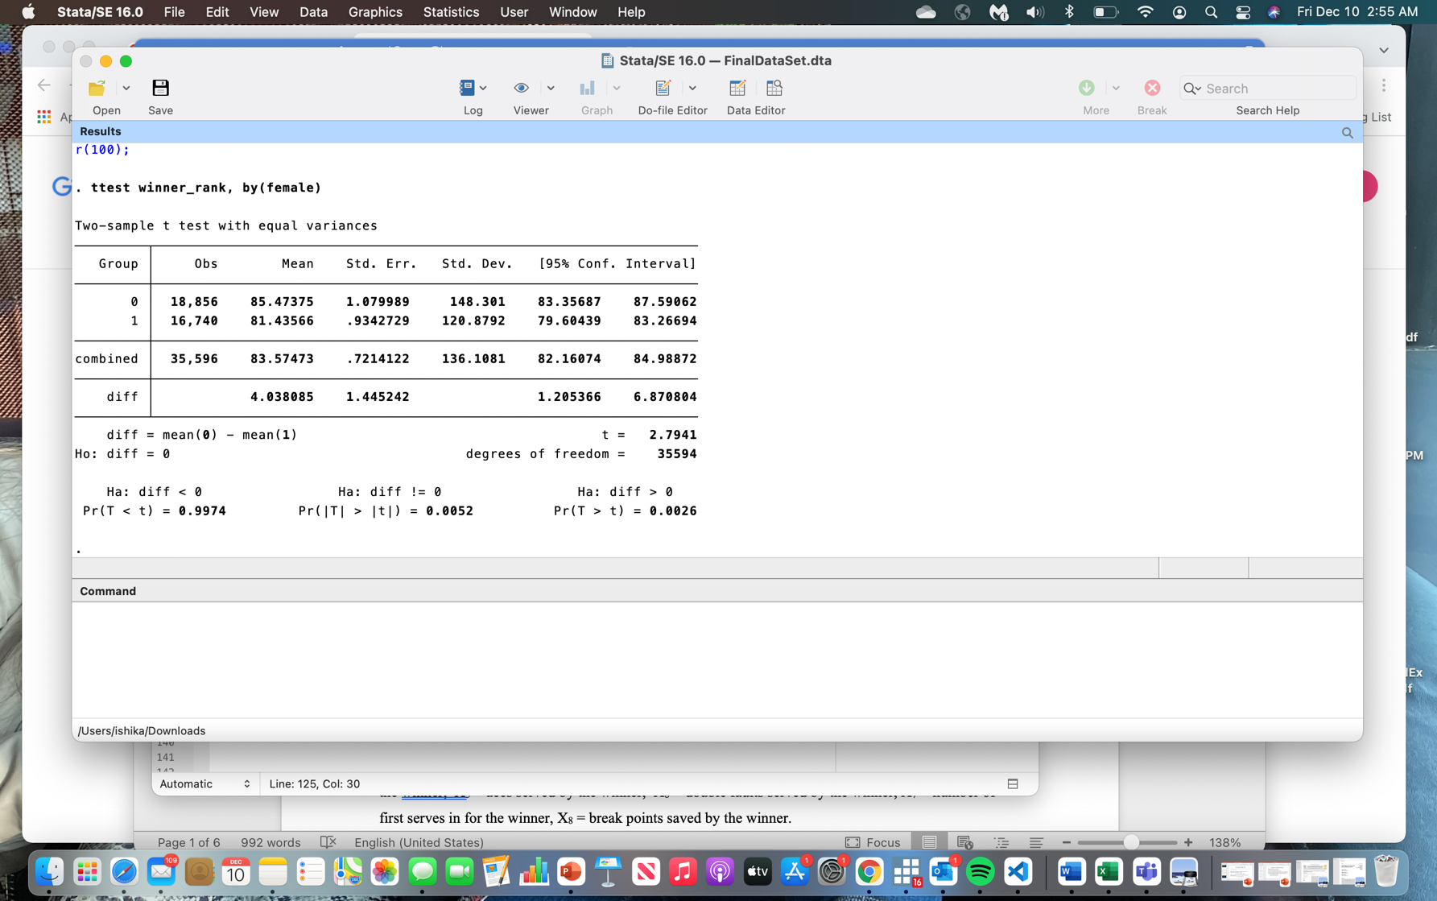

Figure 1: Ttest to test whether rankings are different for females than males

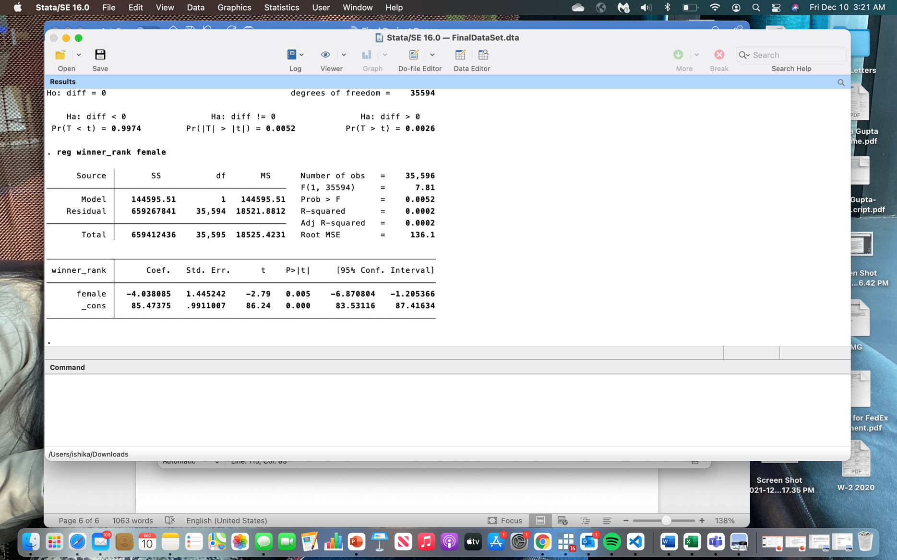

Figure 2: Regression estimate of females on winner ranks

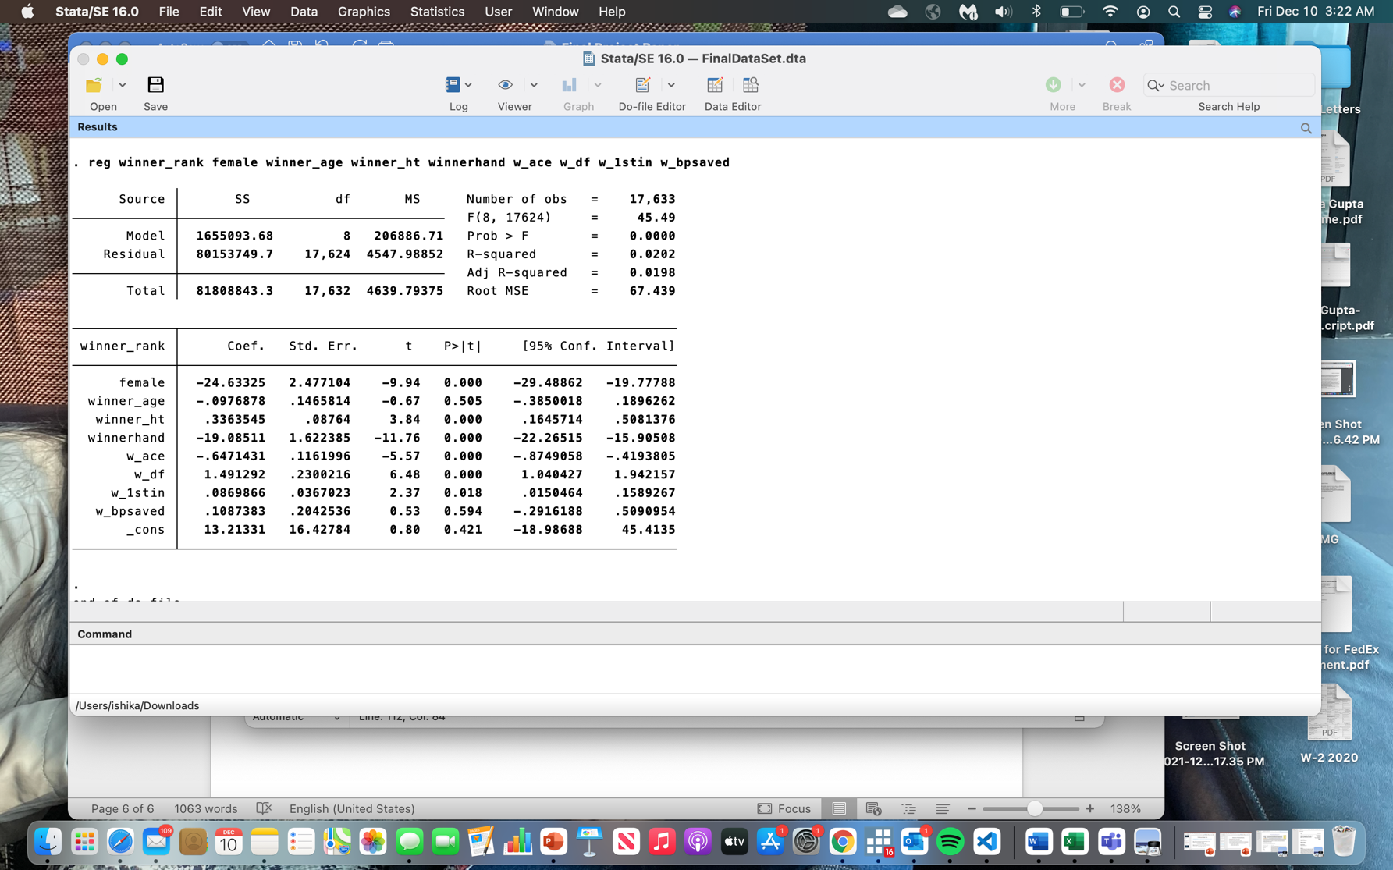

Figure 3: Regression estimate of winner statistics on winner rank

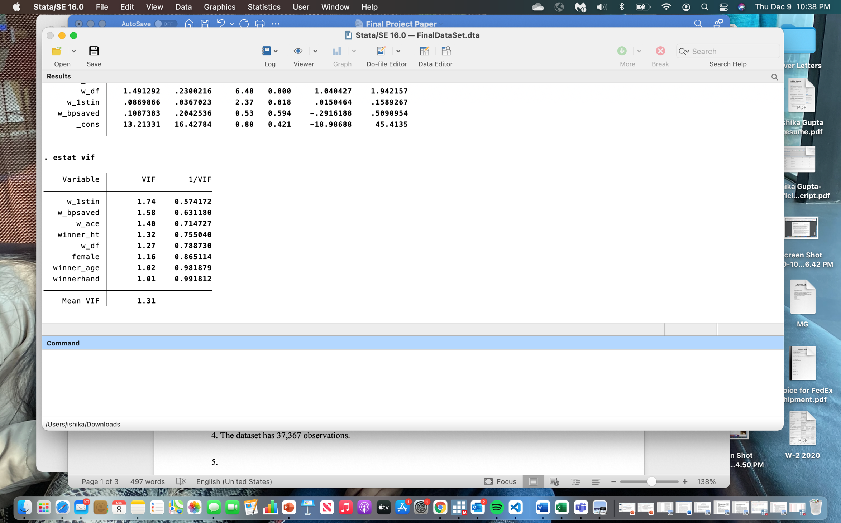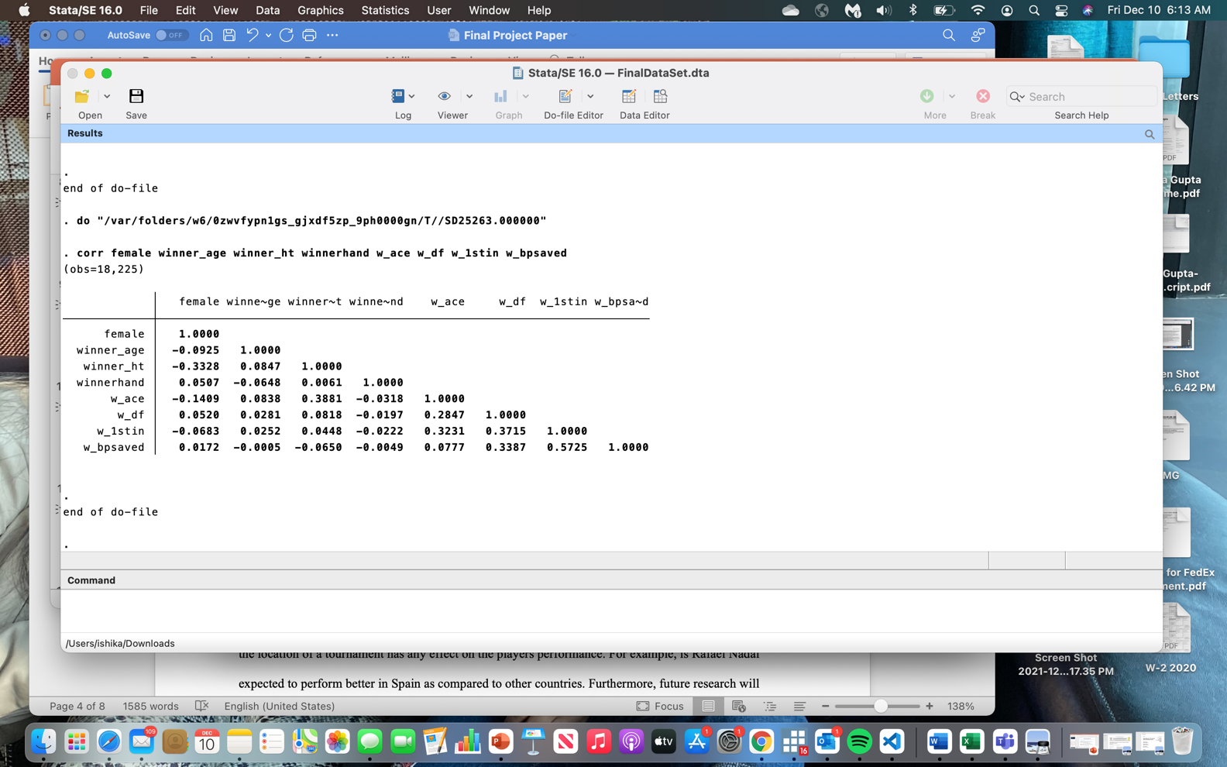

Figure 3: Checking for multicollinearity



Figure 4: Checking for heteroskedasticity (White test)

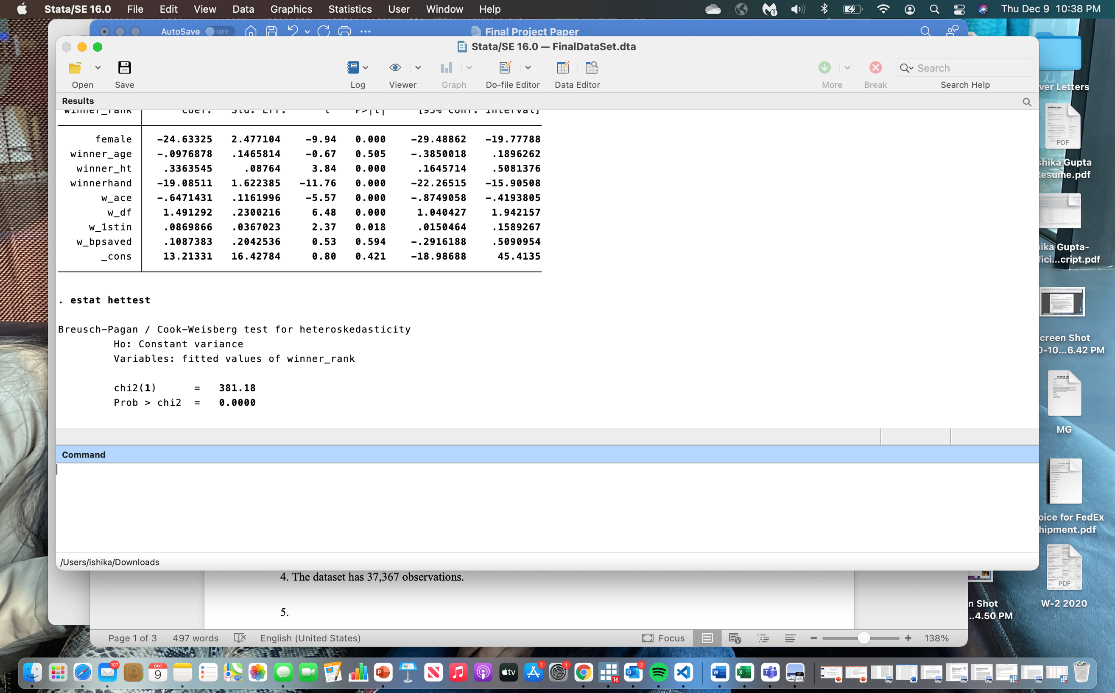

Figure 5: Checking for heteroskedasticity (Breusch-Pagan test)